Measuring the Effect of Presidential Candidate Visits on Newspaper Mentions
By: J. Monroe Gamble IV
Introduction
In this analysis, we use county-level panel data to investigate the effect of a presidential candidate’s visit on the amount of local newspaper coverage that the candidate receives. We estimate a simple OLS model in addition to an impulse response function.
Data
Our raw dataset consists of 18,795 observations at the county-level for the year 2000. There are 89 counties from 21 states plus the District of Columbia. The dataset includes counts for the number of times that a candidate’s name is mentioned in an article or headline. This allows us to assess the impact of a candidates visit on headlines and in-article citations separately. We also combine all mentions to measure the net effect of visits for all of the candidates. These separations allow us to provide an added level granularity.
There are six candidates in our data set. In table 1, we order the candidates by total mentions. In doing so, we see a wide dispersion in mentions between the top and bottom candidates. Accounting for political affiliation, we observe that the majority party’s nominees received substantially more media coverage.
Table 1. Newspaper Article Counts
Rank | Candidate | Count | Headline | In-text | Party
1 | Bush | 157,059 | 26,408 | 130,651 | Republican
2 | Gore | 129,643 | 21,557 | 108,086 | Democrat
3 | Bradley | 18,880 | 2,598 | 16,282 | Democrat
4 | Cheney | 17,032 | 2,099 | 17,032 | Republican
5 | Lieberman | 12,277 | 1,734 | 10,543 | Democrat
6 | Buchanan | 2,079 | 198 | 1,881 | Reform Party

Examining the data, we find that the dataset includes newspaper mentions that occurred after the general election on November 7, 2000. After the election, the candidates did not record any visits likely because they were done campaigning. Therefore, we exclude mentions made after November 7, 2000. We also drop Pat Buchanan from our sample because he does not have any campaign visits in our sample table 2. Dick Cheney and Bill Bradley withdrew from the presidential primaries on March 9, 2000. After March 9th, our dataset does not have any recorded visits by Bradley.
Table 2. Visits by Candidate Prior to Election
Bush | Gore | Bradley | Cheney | Lieberman | Buchanan
37 | 47 | 5 | 5 | 5 | 0

Dick Cheney was selected as George W. Bush’s vice-presidential running mate. Chaney made five visits between his primary resignation and the general election. Joe Lieberman, Al Gore’s running mate, also had five appearances during this time. Lieberman has no appearances prior to Mach 9th. This creates a tricky problem as we have an unbalanced panel. Joe Lieberman’s newspaper mentions should not be included in our analysis prior to his entrance. Lieberman’s first visit was on August 22, 2000, so prior mentions are not attributable to a visit. Similarly, Dick Chaney does not have any visits in our dataset prior to August 31, 2000. Thus, we exclude Chaney’s mentions prior to this period. As running mates, it is difficult to parse the impacts of the Chaney and Lieberman’s visits from the Bush and Gore respectively. The 2000 Democratic National Convention (DNC) ended on August 17, 2000 and the Republican National Convention (RNC) ended on August 3, 2000. For the periods after, any vice presidential mention is likely linked to the presidential candidate.
Our dataset does not include the original texts, so we are unable to conduct a textual analysis to be sure whether Cheney and Lieberman’s mentions correspond to their visits. Due to this we drop the vice presidential candidates visits and focus on the presidential candidates. Table 3 shows our revised article counts in addition to the total number of visits made by each presidential candidate in our sample.
Table 3. Newspaper Mentions & Visits
Rank | Candidate | Count | Headline | In-text | Visits
1 | Bush | 118,224 | 20,789 | 97,435 | 37
2 | Gore | 99,784 | 17,521 | 82,263 | 41
 | Total | 218,008 | 38,310 | 179,698 | 78
*Includes the month of August

Our first recorded bush trip occurred on February 22nd while Gore’s first recorded visit was on February 10th. The number of visits by the Bush and Gore are similar at 37 and 41 respectively. We note that on October 31, 2000 Bush and Gore both visit Santa Clara county, California.
Model & Methodology
We estimate a simple OLS model in addition to an impulse response function. All regressions use heteroskedasticity robust standard errors.
We use county fixed effects to account for differences across counties that are correlated overtime (e.g. population, demographics, political leanings, number of media outlets, etc.), time fixed effects to account for time-dependent changes affecting news coverage across counties (e.g. days until the election, the current president’s political affiliation, changes to laws such as campaign contribution limits, etc.), and lastly we run separate regressions to account for candidate effects – characters that differ across individuals, but are consistent over time (e.g. party affiliation, tastes, skill-level, etc.).
Our variable of interest is newspaper mentions while our explanatory variable is the number of visits. We run five basic OLS regressions (table 1a). In regression 1, we regress all mentions on all visits using county and time fixed effects. In regressions 2 and 3, we look at the effects of visits on headline and in-text mentions. In regressions 4 and 5, we separate mentions by candidates – George W. Bush and Al Gore. After a candidate visits, we expect to see the largest spike in mentions in the days after their visit and not the day of. Thus, we add a lagged variable and repeat regressions 1 through 5 (table 1b). In the same vain, we would like to compare the difference in coverage on a “normal” day to the coverage after a visit. We add a lead variable to capture coverage in the days prior to the visit and re-run our regressions.
$${Mentions}_{c,t-3}= φ_{1}{Visit}_{c,t}+{φ_{2}Mentions}_{c,t+7}+ ε_{c,t}$$
In our analysis, we choose to exclude the month of August to eliminate the effects of each party’s national convention on news article mentions. Though the conventions affect coverage across all counties we cannot rule out differences in magnitudes of influence to amongst counties using fixed effects. For example, the convention affects the county in which it’s hosted disproportionately.
Results
Using an impulse response function we conduct our analysis over a ten day period and find that there is a spike in coverage in the days after a candidate’s visit. The largest spike happens on day one and then increased coverage persists for approximately three days. After this period, the coverage become negative possibly due to the “fatigue” of increased coverage in the days prior. Figures 1-5 displays our results.
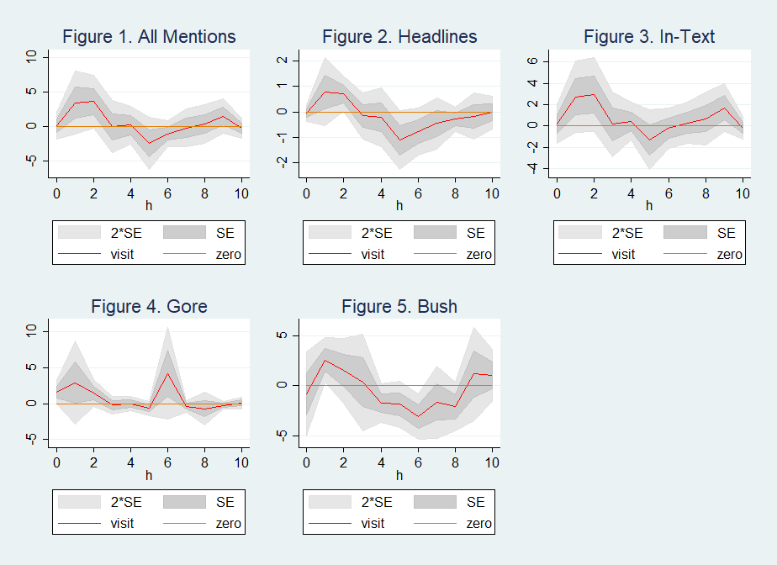
Beginning with figure 1, we find that for all mentions there is approximately a three day window in which we see increased coverage. In the following days we see fewer mentions possibly due to coverage fatigue. Figures 2 and 3 lead us to believe that figure 1’s result is largely driven by in-text references. Looking at the axis of headlines and in-text citations, we note that the scaling of the axis is larger for in-text references. From table 3, we know that there more than five times the number of in-text mentions than headline mentions. Also, we see that all mention’s behavior more closely follows in-text’s mentions path. Headlines and in-text mentions move in opposite directions between day 1 and 2. In-text citations increase while headline counts decrease. Intuitively, this makes as there likely will be less headlines as coverage shifts away from the visit. In figures 4 and 5, we plot impulse response functions by candidate. Bush’s coverage followers a similar trajectory to figures 1, 2 and 3 while Gore’s newspaper coverage is less clear. On day six we see an unexplained spike in coverage. In all the figures, the coverage appears normalize around day seven or eight. Thus we run regressions 1 through 5 with one-week lags and 3 day leads (table 4).
Table 4. Newspaper Mentions 1-day Lead 7-day Lag
 | (1) | (2) | (3) | (4) | (5)
 | All Mentions | Headline Mentions | In-Article | Al Gore | George Bush
visit_flag | 2.532 | 0.718 | 1.896
 | (1.26) | (1.17) | (1.26)
L7.all_mentions | 0.379***
 | (11.19)
L7.all_hcount |  | 0.242***
 |  | (6.91)
L7.all_counts |  |  | 0.383***
 |  |  | (11.40)
visit_gore |  |  |  | 0.864
 |  |  |  | (0.70)
L7.gore_total |  |  |  | 0.387***
 |  |  |  | (10.07)
visit_bush |  |  |  |  | 3.901
 |  |  |  |  | (1.66)
L7.bush_total |  |  |  |  | 0.314***
 |  |  |  |  | (10.07)
Constant | 6.185*** | 0.885*** | 5.305*** | 3.462*** | 2.759***
 | (12.69) | (8.52) | (12.13) | (9.67) | (12.41)
Observations | 24024 | 24024 | 24024 | 24024 | 24024
R-squared | 0.406 | 0.284 | 0.408 | 0.402 | 0.381
County fixed effects | yes | yes | yes | yes | yes
Time fixed effects | yes | yes | yes | yes | yes
Robust standard errors | yes | yes | yes | yes | yes
t statistics in parentheses
* p < 0.05, ** p < 0.01, *** p < 0.001
In each, regression coefficient on our visit flag is positive and not statistically significant while the coefficient on the lagged variable is positive and statistically significant. For all mentions we have an R-value of 0.406. This value drops to 0.284 for headline mentions, but is otherwise stable. As noted earlier, this is likely due to fewer headline observations in our data.
Discussion
Our results, show increased coverage in days after a visit. That said, our coefficient on visit is not statistically significant and our regressions are in need of improvements to increase the accuracy of our statement. When we create impulse response functions exceeding 15 days the data appears cyclical. Approximately, every seven days there is a cycle in coverage. Candidate mention’s spike and then dip into negative territory before returning to near zero. Controlling for days of the week does not improve our results due to collinearity.
Ideally, we would control directly for population, demographics, and the size a county’s media market. Population, size, and demographic information can be attained using data from the United States Census Bureau’s American Community Survey (ACS). With ACS data we can account for the size of the county by land area and population. Demographic data may proxy political leanings. Historically, African-American majority counties are blue. Thus we would expect more news mentions for candidates who are Democrats. Counties that are rural and majority white are likely to be red; therefore, we’d expect more mentions of Republican candidates. Also, there may be differences in magnitudes when measuring the impact of a visit (e.g. when a Republican visits a Democratic county and vice versa). A dummy variable for the historical party leaning – the political party of the candidate who carried the most votes in the previous election – may be an alternative method for accounting for these characteristics. A concern with both methods would be reverse causality. Candidates likely focus more on counties they see as winnable, so they may choose to visit counties based on these characteristics.
Another improvement would be the inclusion of market size in addition to filtering for local, regional, and national newspaper distribution. Local papers may provide a better picture as their reporting focuses on local events. Regional and national papers may create an upward bias in the counties that they are published when they report of events outside of the county. Our experimental design helps account for some of this because we try to compare coverage after a visit to the county’s ”normal” coverage. We do this by comparing changes in mentions to the mentions prior to the visit, but this is imperfect. The LA Times is considered local in Los Angeles County, but no local in Autauga County Alabama. This is okay, because they LA Times may be reporting on local visit, however, if the LA Times reports on a campaign visit in Autauga with this would create upward bias our LA County estimates.
Lastly, bias is introduced because the data does not account for the spillover of visits on neighboring counties. It is likely that local visits reported on in Marion County, Indiana will overlap with mentions in Bartholomew County, Indiana. The Indianapolis Star is distributed across the state and is a major news outlet, thus the fact that it is located in Marion county may create upward bias. Limiting our date ranges 3 days prior to and 7 days after helps with this, however, sometimes these windows may overlap if a candidate visits multiple neighbors in this time period. Our sample likely suffers from omitted variable because we are not easily able to control for this. We can look for multiple visits to the same county. There are two days in which multiple candidates visit the same county February 10th (Bradley-Gore) and October 31st (Gore-Bush).
Conclusion
Our results show that there may be a positive correlation between campaign visits and newspaper article mentions. We find that there is a large spike in coverage the day after a visit. On days two and three coverage remains positive before going negative and then back to “normal”. This happens over a span of seven days. Expanding our date range to 15 or 30 days after a visit our results become noisy as coverage appears to be cyclical. Further, obfuscating a clear result is the lack of population and demographic data to properly account for differences across counties. Though we use county fixed effects we cannot be sure that we have accounted for all changes within counties across time. Furthermore, our regression results for visits is not significant.

Appendix

Table 4. Top 9 Visits by County
Rank | Visits | County | State
1 | 16 | Los Angeles | CA
2 | 14 | District of Columbia | DC
3 | 10 | Santa Clara | CA
4 | 7 | Lake | IL
5 | 5 | Dade | FL
6 | 4 | Broward | FL
7 | 3 | Volusia | FL
8 | 3 | Cook | FL
9 | 3 | Palm Beach | CA

Table 5. Top 10 Mentions by County
Rank | Mentions | County | State
1 | 24,729 | Los Angeles | CA
2 | 20,405 | Alameda | CA
3 | 19,888 | Bartholomew | IN
4 | 14,446 | Contra Costa | CA
5 | 13,328 | Middlesex | MA
6 | 12,338 | Hampden | MA
7 | 11,642 | Marion | IN
8 | 10,860 | Whitley | IN
9 | 10,212 | Nevada | AR
10 | 10,109 | Santa Clara | CA

Table 1a. Newspaper Mentions
 | (1) | (2) | (3) | (4) | (5)
 | All Mentions | Headline Mentions | In-Article | Al Gore | George Bush
visit_flag | 0.0897 | 0.0723 | 0.0174
 | (0.07) | (0.23) | (0.02)
visit_gore |  |  |  | 0.403
 |  |  |  | (0.42)
visit_bush |  |  |  |  | 0.817
 |  |  |  |  | (0.61)
Constant | 1.165 | 0.0659 | 1.099 | 0.538 | 0.626
 | (1.33) | (0.38) | (1.54) | (1.39) | (1.27)
Observations | 25480 | 25480 | 25480 | 25480 | 25480
R-squared | 0.325 | 0.244 | 0.327 | 0.318 | 0.332
County fixed effects | yes | yes | yes | yes | yes
Time fixed effects | yes | yes | yes | yes | yes
Robust standard errors | yes | yes | yes | yes | yes
t statistics in parentheses
* p < 0.05, ** p < 0.01, *** p < 0.001

Table 1b. Newspaper Mentions 7-day Lag
 | (1) | (2) | (3) | (4) | (5)
 | All Mentions | Headline Mentions | In-Article | Al Gore | George Bush
visit_flag | -1.100 | -0.138 | -0.860
 | (-0.75) | (-0.57) | (-0.68)
L7.all_mentions | 0.549***
 | (13.40)
L7.all_hcount |  | 0.341***
 |  | (7.92)
L7.all_counts |  |  | 0.565***
 |  |  | (14.37)
visit_gore |  |  |  | -0.469
 |  |  |  | (-0.34)
L7.gore_total |  |  |  | 0.485***
 |  |  |  | (12.32)
visit_bush |  |  |  |  | 0.323
 |  |  |  |  | (0.29)
L7.bush_total |  |  |  |  | 0.523***
 |  |  |  |  | (13.19)
Constant | 3.910*** | 0.758*** | 3.148*** | 2.157*** | 1.804***
 | (11.02) | (7.62) | (11.18) | (8.90) | (9.30)
Observations | 24206 | 24206 | 24206 | 24206 | 24206
R-squared | 0.491 | 0.320 | 0.500 | 0.449 | 0.462
County fixed effects | yes | yes | yes | yes | yes
Time fixed effects | yes | yes | yes | yes | yes
Robust standard errors | yes | yes | yes | yes | yes
t statistics in parentheses
* p < 0.05, ** p < 0.01, *** p < 0.001

